LAB 04:

1. Implement the above code and paste the screenshot of the output

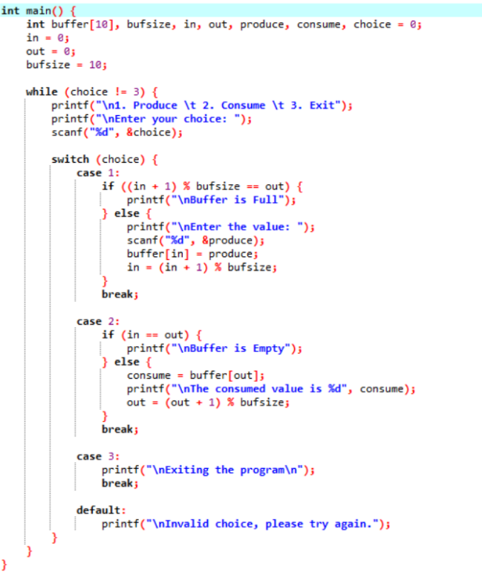

**OUTPUT:**

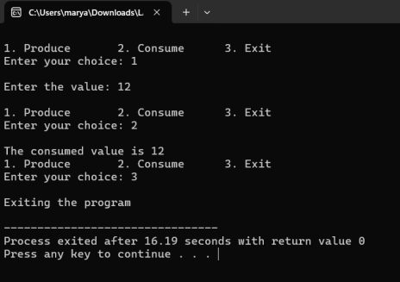

2) Solve the producer-consumer problem using linked list. (You can perform this task usingany programming language)

Note: Keep the buffer size to 10 places

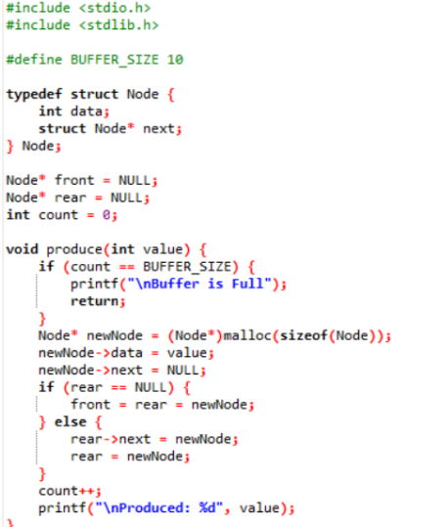

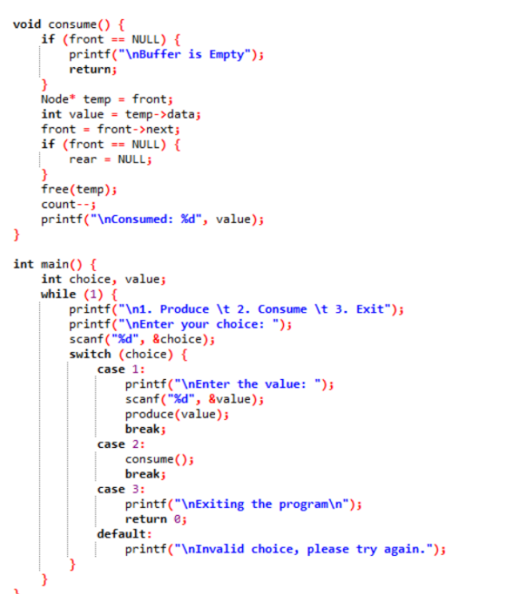

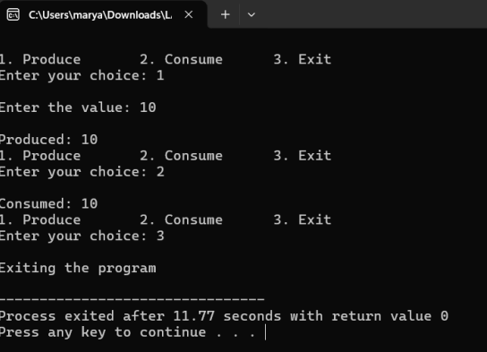

3. In the producer-consumer problem, what difference will it make if we utilize a stack for the buffer rather than an array?

**ANSWER:** Using a stack instead of an array (queue) in the Producer-Consumer problem

changes the order of consumption:

● Queue (FIFO): The oldest item is consumed first.

● Stack (LIFO): The newest item is consumed first.

This can lead to older items being left in the buffer, which may not be ideal for real-time

processing. However, it can be useful in scenarios where recent data is prioritized